AMNA MANSOOR 22K-5159 BSE-3B DS LAB

**TASK 1:**

*CODE:*

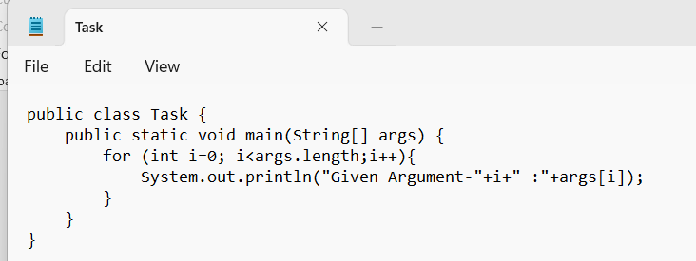

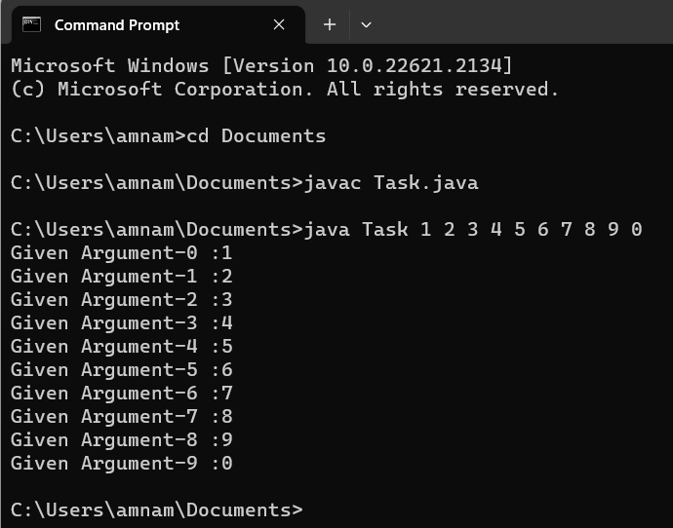

**TASK 2:**

import java.util.Scanner;  
  
public class Task2 {  
 public static void main(String[] args) {  
 Scanner sc=new Scanner(System.*in*);  
 System.*out*.println("Enter the number of elements in the array: ");  
 int n= sc.nextInt();  
 int[] array=new int[n];  
 System.*out*.println("Enter the elements of the array:");  
 for (int i = 0; i < n; i++) {  
 array[i] = sc.nextInt();  
 }  
 System.*out*.print("Enter the number of steps to rotate: ");  
 int steps = sc.nextInt();  
  
 *rotate*(array, steps);  
  
 System.*out*.println("Rotated Array:");  
 for (int arr : array) {  
 System.*out*.print(arr + " ");  
 }  
  
 }  
 public static void rotate(int[]array, int steps){  
 int n = array.length;  
 int[] temp = new int[n];  
  
 for (int i = 0; i < steps; i++) {  
 temp[i] = array[i];  
 }  
 for (int i = steps; i < n; i++) {  
 array[i - steps] = array[i];  
 }  
 for (int i = 0; i < steps; i++) {  
 array[i + n - steps] = temp[i];  
 }  
 }  
}

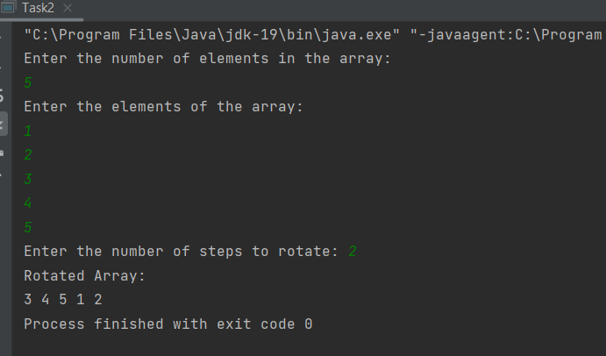

**TASK 3:**

import java.util.Scanner;  
  
public class Task3 {  
 public static void main(String[] args) {  
 int array1[][]=new int[3][3];  
 int array2[][]=new int[3][3];  
 int addArray[][]=new int [3][3];  
 Scanner sc=new Scanner(System.*in*);  
  
 System.*out*.println("Enter elements of array 1");  
 for (int i=0; i<array1.length; i++){  
 for(int j=0;j<array1[i].length;j++){  
 array1[i][j]=sc.nextInt();  
 }  
 }  
 System.*out*.println("Enter elements of array 2");  
 for (int i=0; i<array2.length; i++){  
 for(int j=0;j<array2[i].length;j++){  
 array2[i][j]=sc.nextInt();  
 }  
 }  
 for(int i=0;i<addArray.length;i++){  
 for(int j=0;j<addArray[i].length;j++){  
 addArray[i][j]=array1[i][j]+array2[i][j];  
 }  
 }  
 System.*out*.println("Added Array: ");  
 for(int i=0;i<addArray.length;i++){  
 for(int j=0;j<addArray[i].length;j++){  
 System.*out*.print(addArray[i][j]+" ");  
 }  
 System.*out*.println();  
 }  
  
 }  
}

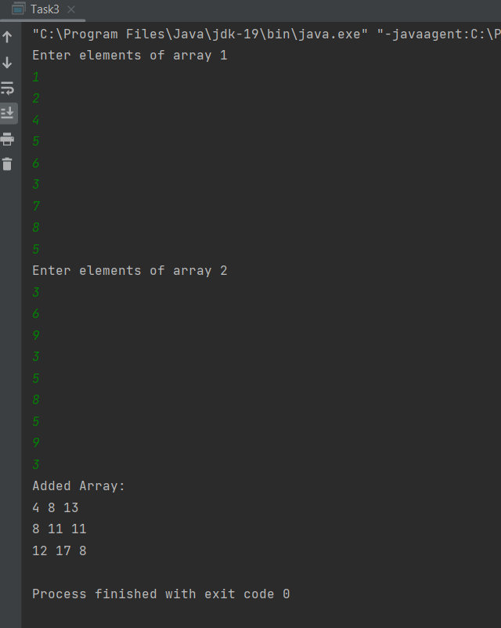

**TASK 4:**

public class Task4 {  
 public static void main(String[] args) {  
 int[][] array = new int[3][];  
 array[0] = new int[6];  
 array[1] = new int[4];  
 array[2] = new int[2];  
 int count = 1;  
 for (int i = 0; i < array.length; i++) {  
 for (int j = 0; j < array[i].length; j++) {  
 array[i][j] = count++;  
 }  
 }  
 System.*out*.println("Jagged Array is: ");  
 for (int i = 0; i < array.length; i++) {  
 for (int j = 0; j < array[i].length; j++) {  
 System.*out*.print(array[i][j]+ " ");  
 }  
 System.*out*.println(" ");  
 }  
 int sum=0;  
 for (int i = 0; i < array.length; i++) {  
 for (int j = 0; j < array[i].length; j++) {  
 sum+=array[i][j];  
 }  
 }  
 System.*out*.println("Sum of all indices of the Jagged Array is: "+sum);  
  
 }  
}

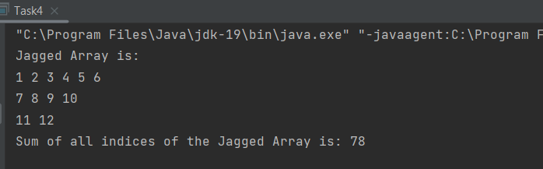

**TASK 5:**

import java.util.Scanner;  
  
public class Task5 {  
 public static void main(String[] args) {  
 int[] array = {10, 11, 14, 16};  
 System.*out*.println("Array:" );  
 *print*(array);  
 int newElement=27;  
 int newLength=array.length+1;  
 int temp[] =new int[newLength];  
 for (int i = 0; i < array.length; i++) {  
 temp[i] = array[i];  
 }  
  
 temp[newLength - 1] = newElement;  
 array = temp;  
 System.*out*.println("\n\nUpdated Array: ");  
 *print*(array);  
  
 int removeElements=2;  
 newLength=array.length-removeElements;  
 temp= new int[newLength];  
 for (int i = removeElements; i < array.length; i++) {  
 temp[i - removeElements] = array[i];  
 }  
 array=temp;  
 System.*out*.println("\n\nArray After removing 2 elements: ");  
 *print*(array);  
  
 }  
 public static void print(int[] array){  
 for (int arr : array) {  
 System.*out*.print(arr + " ");  
 }  
  
 }  
}

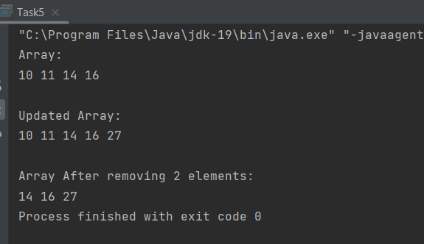

**TASK 6:**

import java.util.Scanner;  
  
public class Task6{  
 public static void main(String[] args) {  
 String[] array=new String[7];  
 Scanner sc=new Scanner(System.*in*);  
 System.*out*.println("Enter names of 6 fruits:");  
 for (int i=0;i<6;i++){  
 array[i]=sc.next();  
 }  
 System.*out*.println("Give name of a person:");  
 array[6]=sc.next();  
 System.*out*.println("\nThe Initial array is: ");  
 for (int i=0;i<7;i++){  
 System.*out*.print(array[i]+" ");  
 }  
 array[6]="orange";  
 System.*out*.println("\n\nUpdated Array is: ");  
 for (int i=0;i<7;i++){  
 System.*out*.print(array[i]+" ");  
 }  
 }  
}

